**Exploring Vehicle Accidents in France**

* This notebook represents the exploration and visualization of the dataset Accidents in France [Dataset](https://www.kaggle.com/ahmedlahlou/accidents-in-france-from-2005-to-2016).
* This data set consists of all the recorded accidents in France since 2005 to 2016.

**Contents**

**1. Exploration based on date of accidents**

* Is the number of Accidents per year decreasing? (from 2005 to 2016)
* Which months have higher frequency of Accidents?
* Which Day-of-the-Month is most safe to drive?
* Time series of all accidents from 2005 to 2016
* Time series for all accidents in each year

**2. Exploration based on roads where accidents occurred**

* Which types of roads are high risk?
* Which type of road gradient is high risk?

**3. Exploration based on people involved in the accidents**

* What was the condition of the people after the accident?
* What was the age distribution of the people involved?
* What was the sex distribution of the people involved?

**4. Exploration based on use of safety equipment**

* What was the distribution of Safety Equipment used?
* Did use of Safety Equipment impact condition of people after the accident?

**1. EXPLORATION BASED ON DATE OF ACCIDENTS**

### IS THE NUMBER OF ACCIDENTS PER YEAR DECREASING?

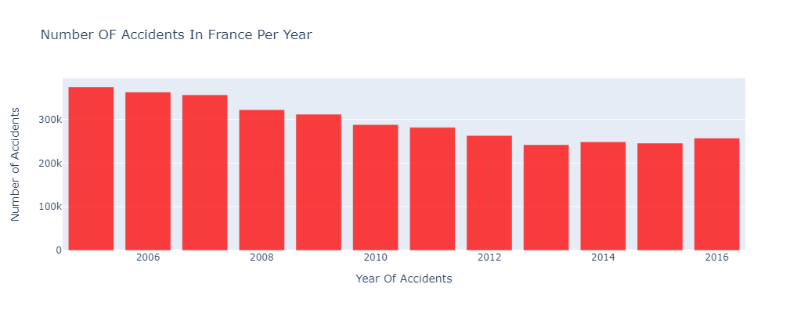

* Number of accidents in France have steadily decreased from 2005 to 2013, but an increasing trend is observed from 2013 to 2016.
* In this dataset, 2005 had the largest number of accidents equal to 374561.

WHICH MONTHS HAVE HIGHER FREQUENCY OF ACCIDENTS?

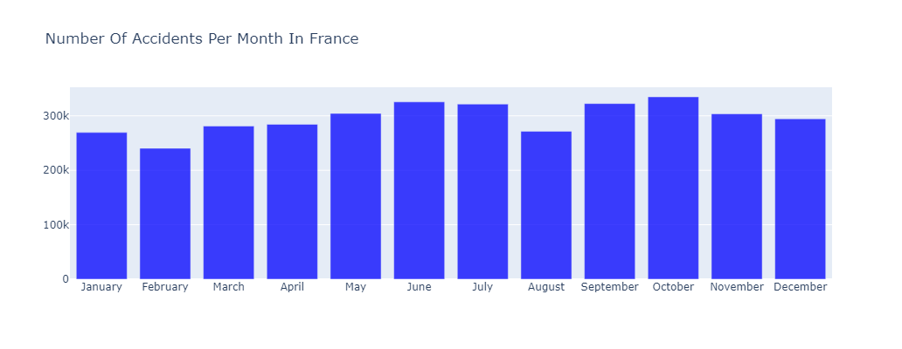

* June, July, September, October have the highest number of accidents, while February has the lowest.
* On an average about 296,164 accidents occur every month in France.
* October has the highest number of accidents (with about 334,884 incidents) than any other month
* Weather in France during September and October is cold and wet whereas, June and July form the peak tourist season

Which Day-of-the-Month is most safe to drive?

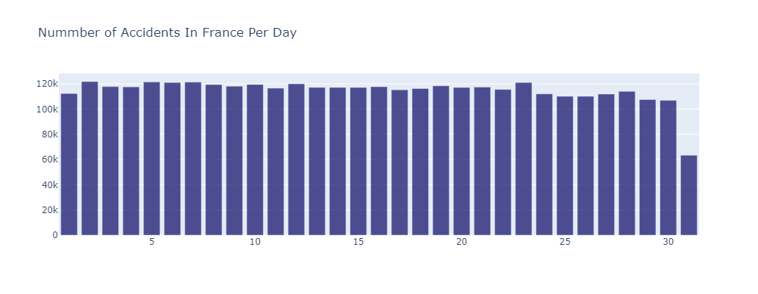

* Number of accidents per month-day is mostly uniform. 31st is lowest because only 7 months have 31 days.
* On an average about 114,644 accidents occur every day in France.

Time series of all accidents from 2005 to 2016?

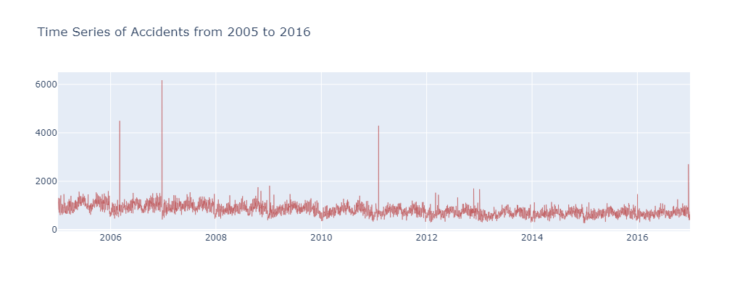

Time series for all accidents in each year?

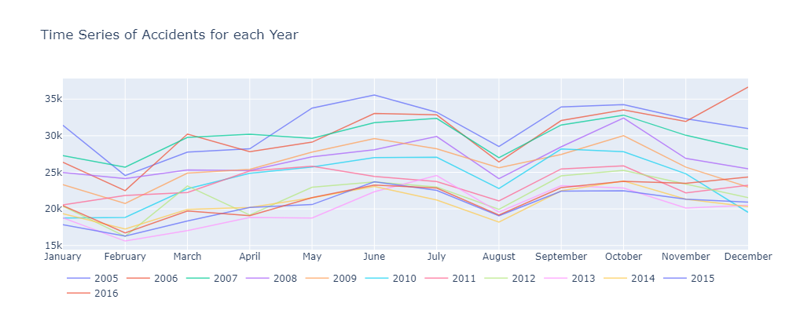

* A sharp rise is observed in the months of June, July, September and October.
* Sharp drops are observed in February and August.
* December, 2006 has the highest number of accidents at 36,648.
* February, 2013 has the lowest number of accidents at 15,605.

**2. Exploration based on roads where accidents occurred**

Which types of roads are high risk**?**

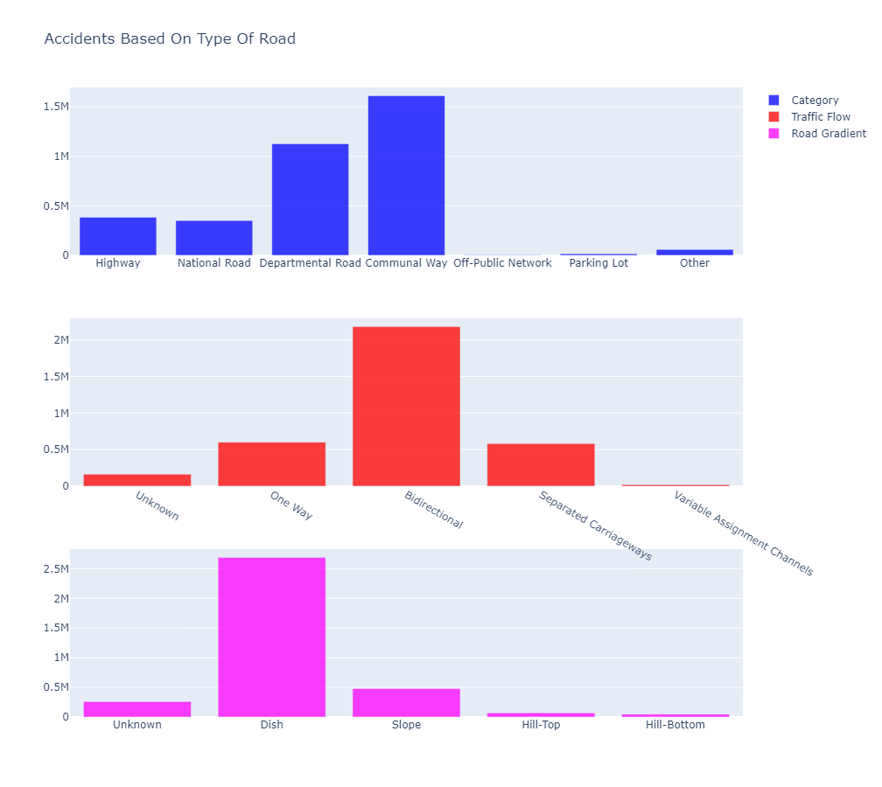

Which type of road gradient is high risk?

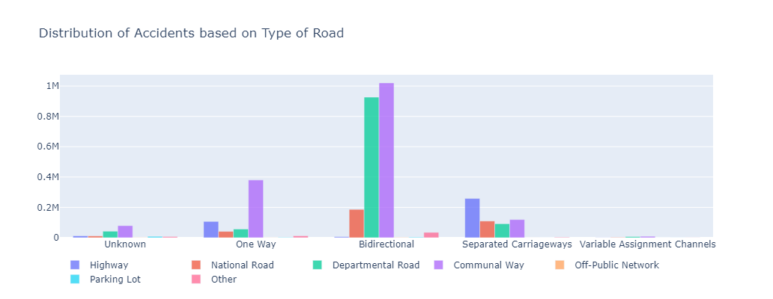

3 Exploration based on people involved in the accidents

What was the condition of the people after the accident?

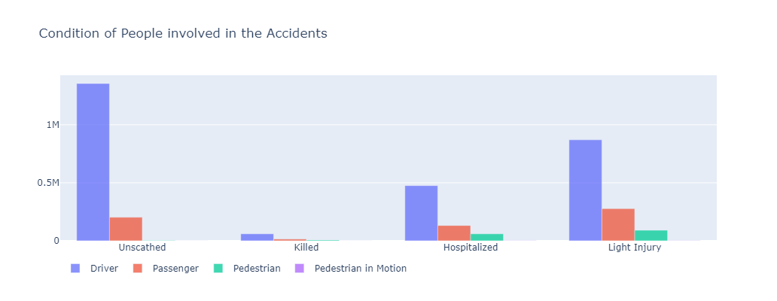

What was the age distribution of the people involved?

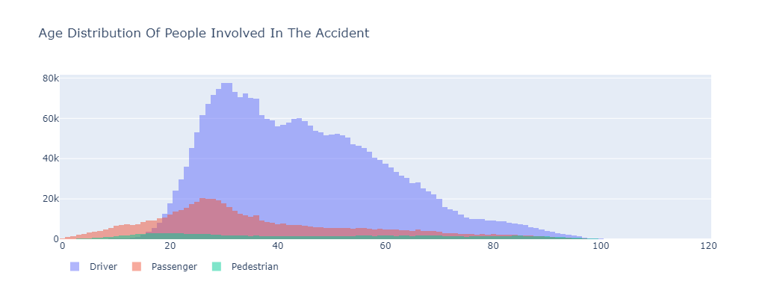

What was the sex distribution of the people involved?

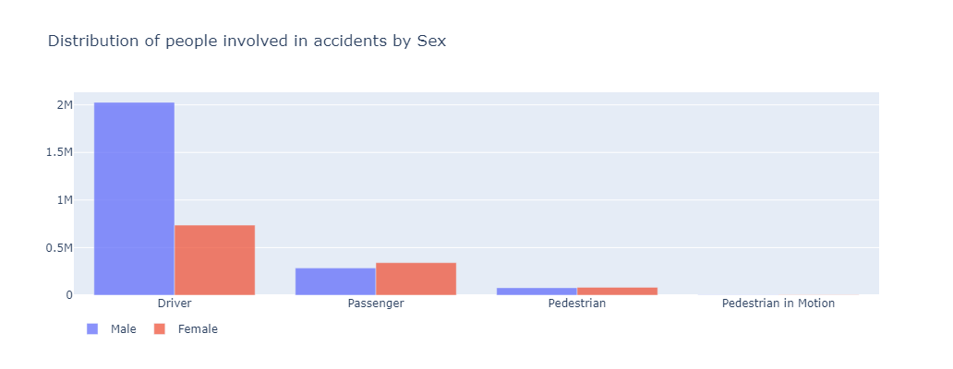

4 Exploration based on use of safety equipment

What was the distribution of Safety Equipment used?

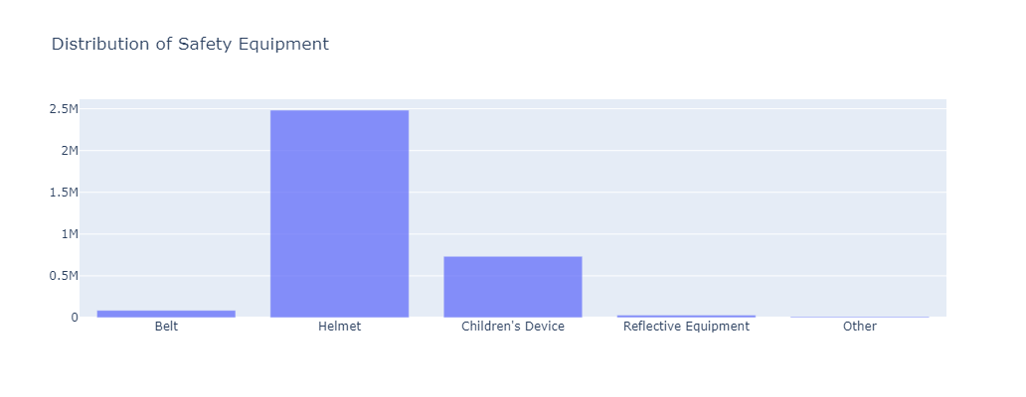

Did use of Safety Equipment impact condition of people after the accident?

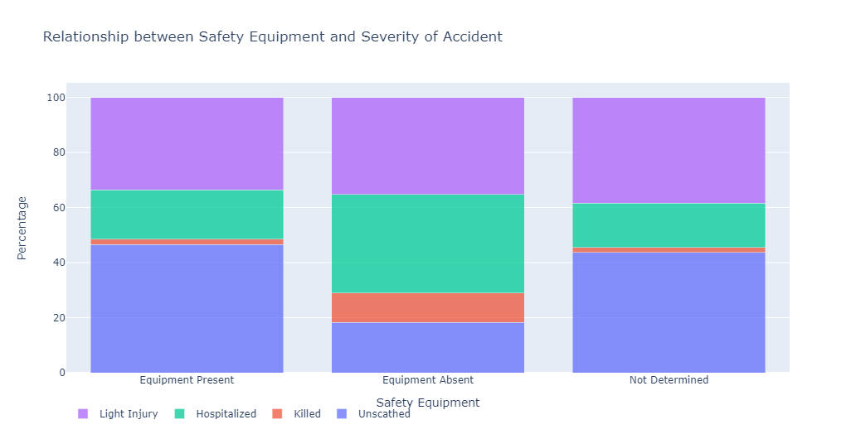

* 1.9% of the people were killed and 17.8% were hospitalized if Safety Equipment was used.
* 10.7% of the people were killed and 35.8% were hospitalized if Safety Equipment was not used.